**6.E-TICKETING**

**USE CASE DIAGRAM**:

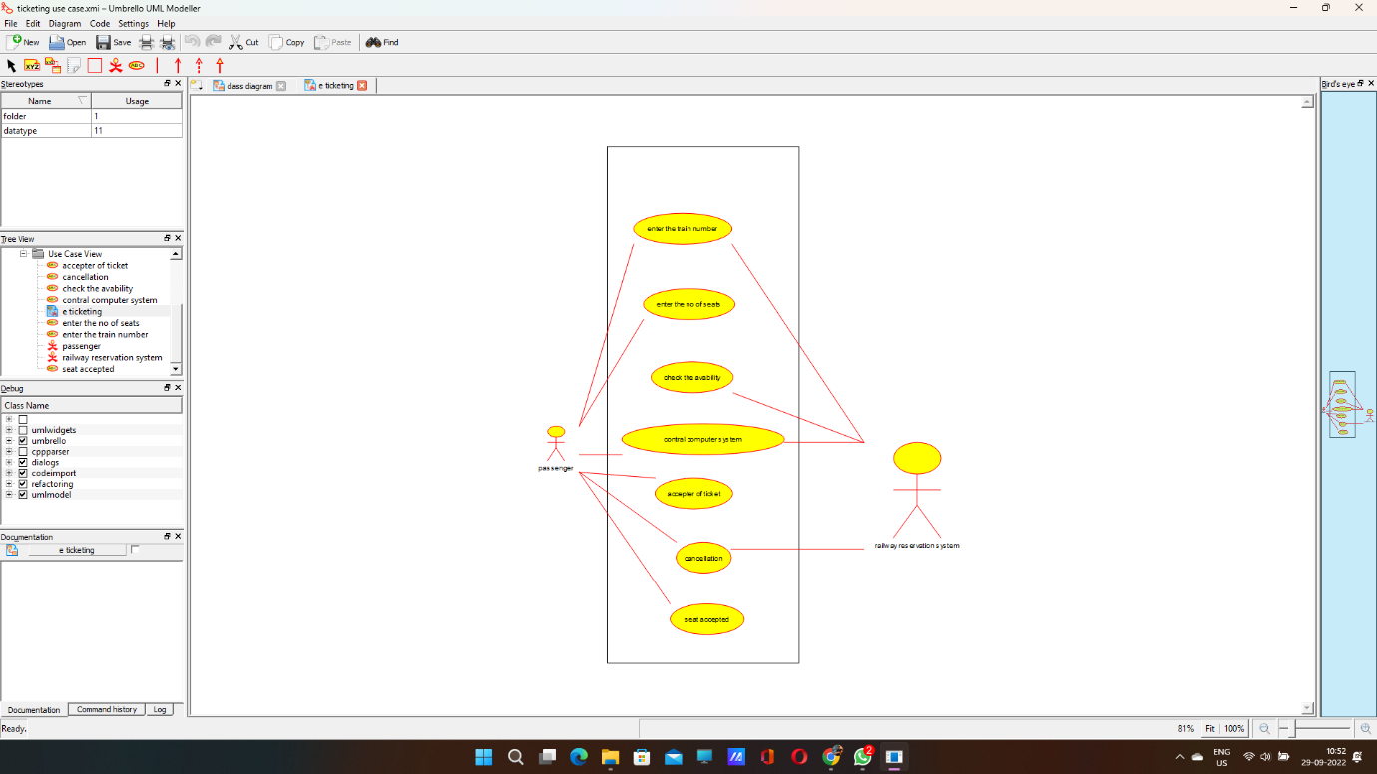

**CLASS DIAGRAM:**

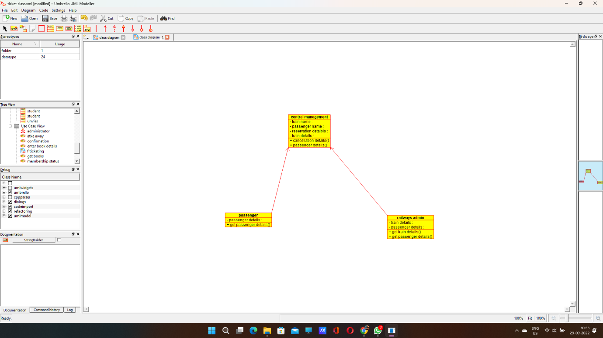

**ACTIVITY DIAGRAM:**

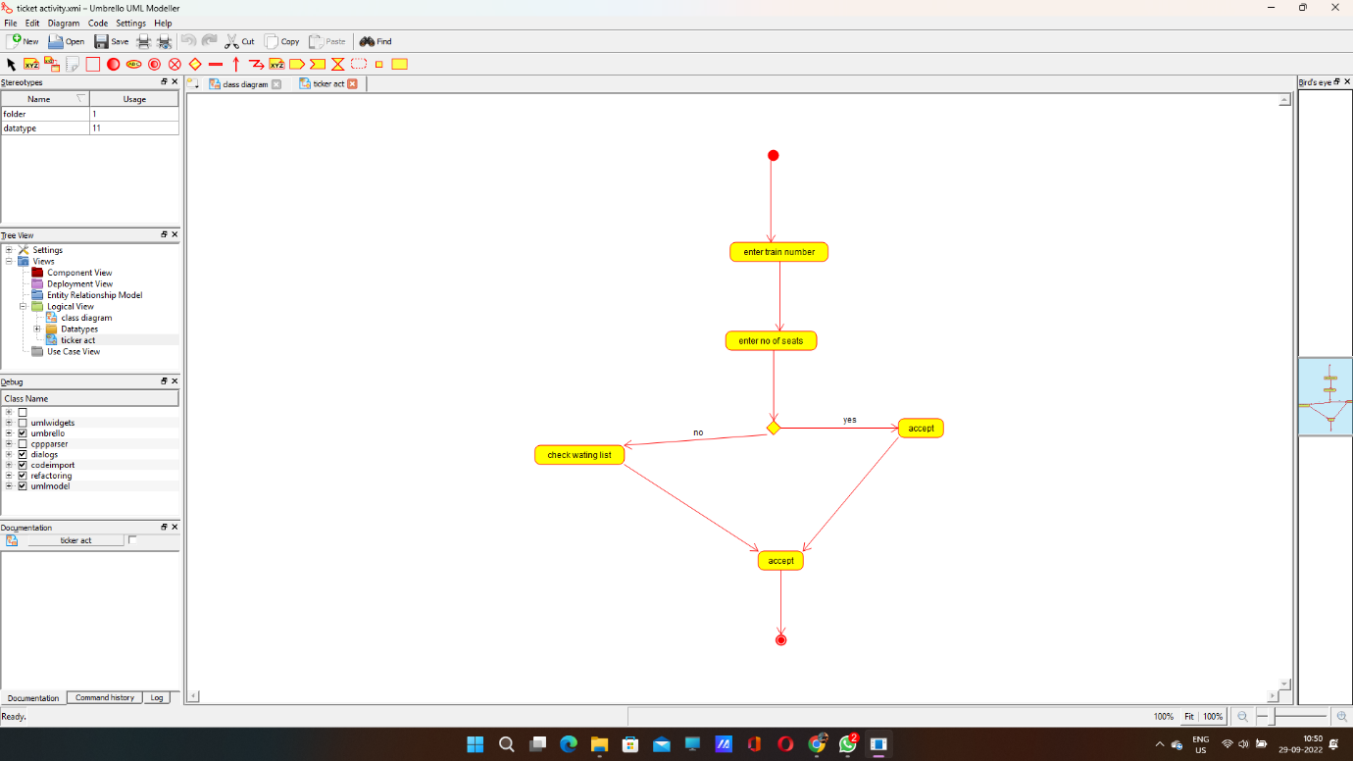

**SEQUENCE DIAGRAM:**

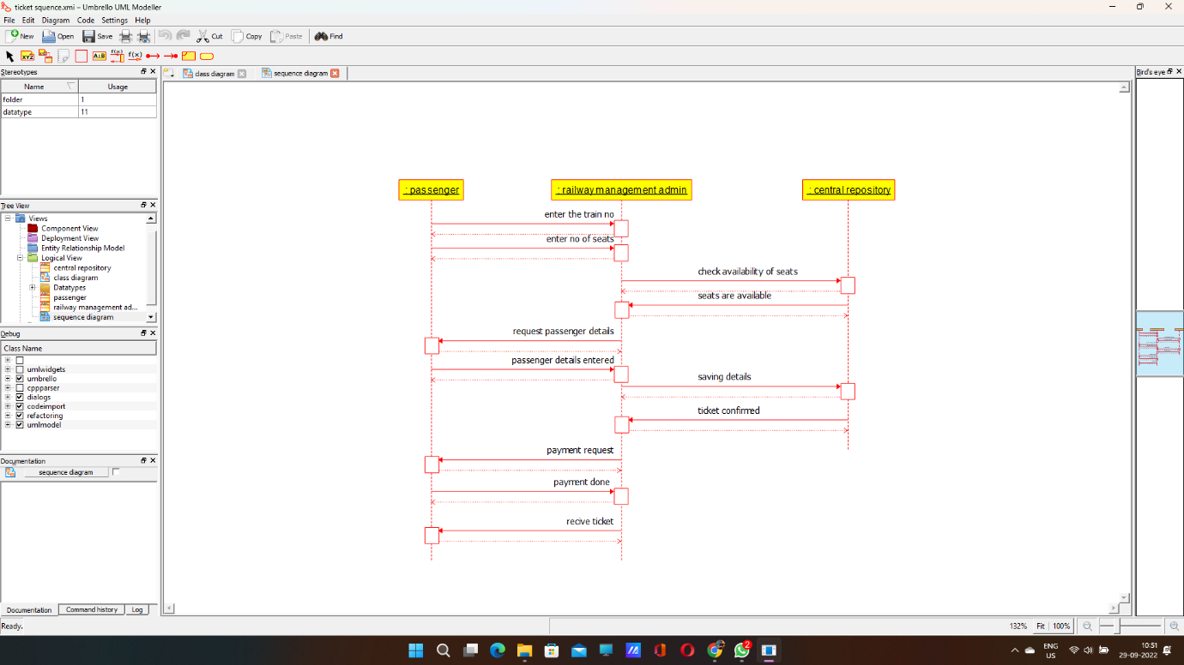

**CALLOBARATION DIAGRAM:** 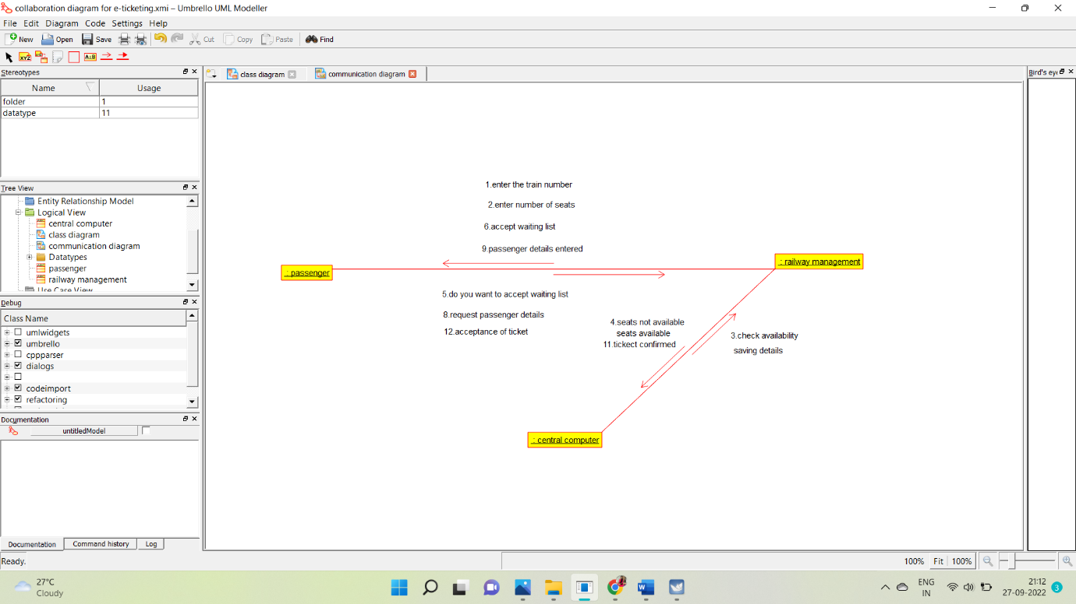

**STATE CHART DIAGRAM**: 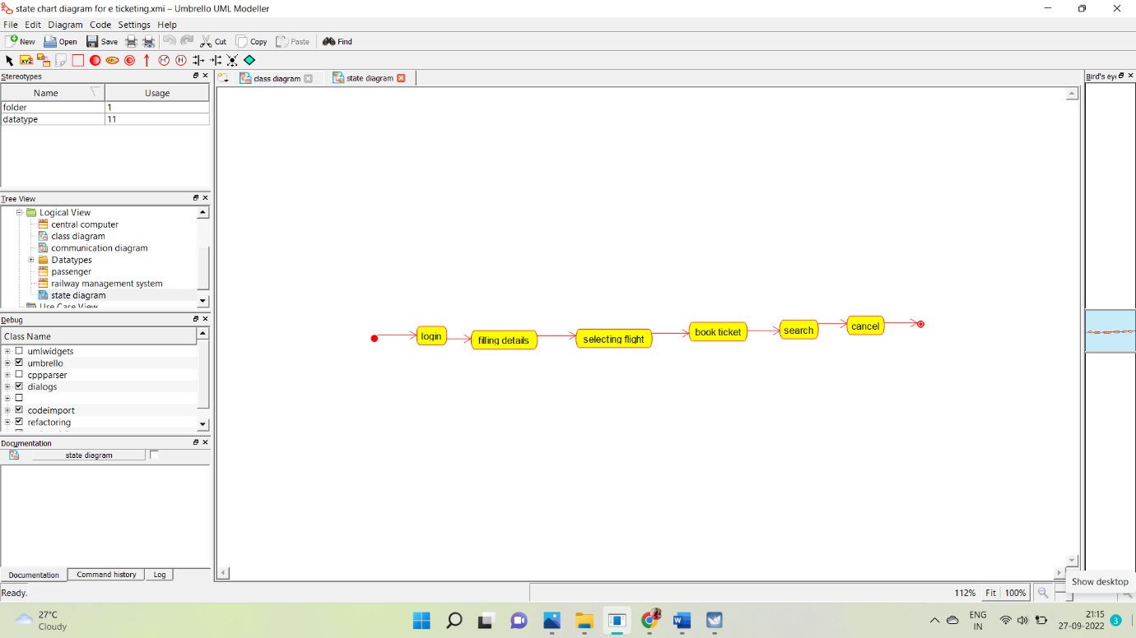

**COMPONENT DIAGRAM:**

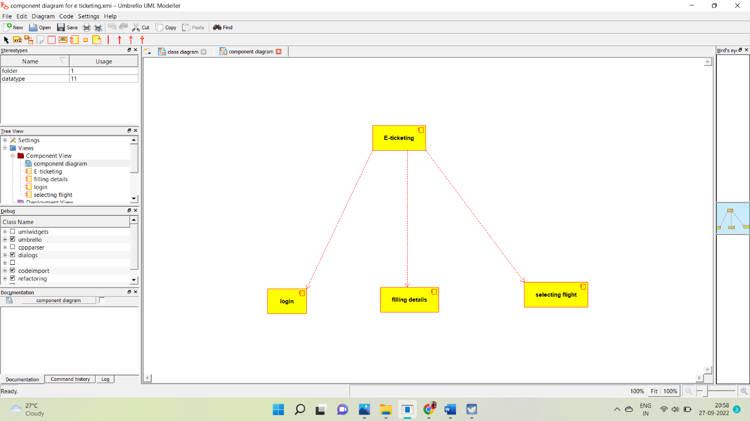

**DEPLOYMENT DIAGRAM:**

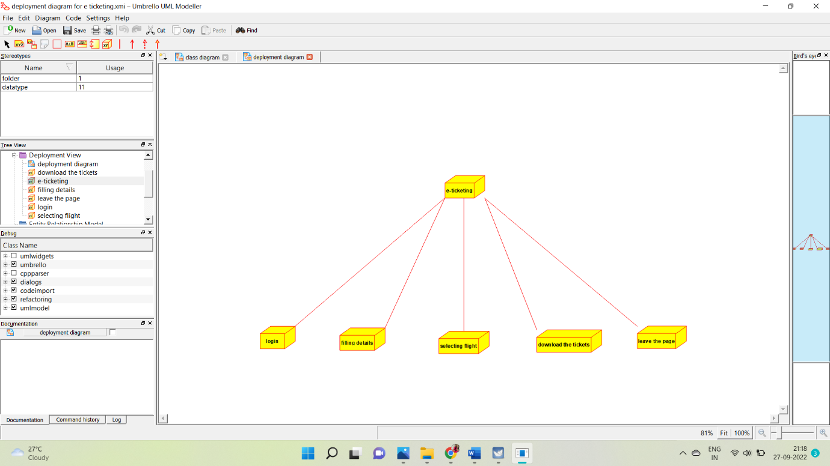

**SKELETON CODE GENERATION:**

/**

* Class admin

*/

public class admin {

//

// Fields

//

//

// Constructors

//

public admin () { };

//

// Methods

//

//

// Accessor methods

//

//

// Other methods

//

}

/**

* Class central_management

*/

public class central_management {

//

// Fields

//

private void train_name;

private void passenger_name;

private void reservation_detaiols;

private void train_details;

//

// Constructors

//

public central_management () { };

//

// Methods

//

//

// Accessor methods

//

/**

* Set the value of train_name

* @param newVar the new value of train_name

*/

private void setTrain_name (void newVar) {

train_name = newVar;

}

/**

* Get the value of train_name

* @return the value of train_name

*/

private void getTrain_name () {

return train_name;

}

/**

* Set the value of passenger_name

* @param newVar the new value of passenger_name

*/

private void setPassenger_name (void newVar) {

passenger_name = newVar;

}

/**

* Get the value of passenger_name

* @return the value of passenger_name

*/

private void getPassenger_name () {

return passenger_name;

}

/**

* Set the value of reservation_detaiols

* @param newVar the new value of reservation_detaiols

*/

private void setReservation_detaiols (void newVar) {

reservation_detaiols = newVar;

}

/**

* Get the value of reservation_detaiols

* @return the value of reservation_detaiols

*/

private void getReservation_detaiols () {

return reservation_detaiols;

}

/**

* Set the value of train_details

* @param newVar the new value of train_details

*/

private void setTrain_details (void newVar) {

train_details = newVar;

}

/**

* Get the value of train_details

* @return the value of train_details

*/

private void getTrain_details () {

return train_details;

}

//

// Other methods

//

/**

*/

public void cancellation_details()

{

}

/**

*/

public void passenger_details()

{

}

}